Складання промта щоб ШІ запропонував порізку для вже сегментованого зображення.

№1
You are a senior wood worker. Your job is to decide, how to cut given piece of veneer. You are given a picture of veneer with defects marked in different colour. You know that large singular pieces are better than small ones. You need to pick the best way to cut the veneer, so that the largest pieces are free from defects.
текст норм але прогавив пару дефектів
+
After that, draw a visual cutting layout over the image.
(відповідь стає тільки зображення, неточна, і займає дуже довго, більше хвилини)
він сам себе загнав у прямокутники
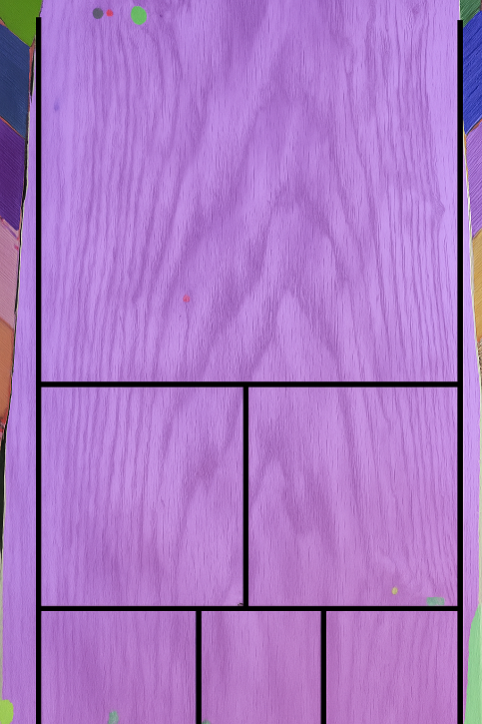

№2
You are a senior wood worker. Your job is to decide, how to cut given piece of veneer. You are given a picture of veneer with defects marked in different colour. You know that large singular pieces are better than small ones.
The output consists of two parts. 1) Text answer, your pick of the best way to cut the veneer, so that the largest pieces are free from defects. 2) Draw a visual of cutting layout over the image.

відповідь все ще тільки зображення, краще його не просити малювати, а просити згенерувати координати, і потім змалювати самому
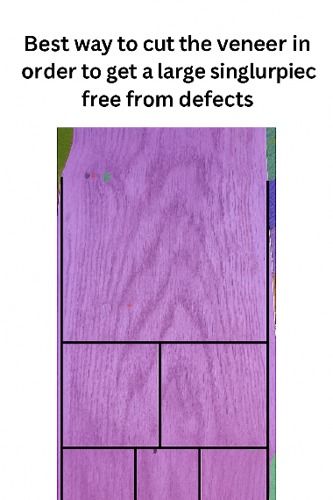

№3
You are a senior wood worker. Your job is to decide, how to cut given piece of veneer. You are given a picture of veneer with defects marked in different colour. You know that large singular pieces are better than small ones. You need to pick the best way to cut the veneer, so that the largest pieces are free from defects.
## Inputs – Veneer shete image, with marked defects on it, and a size of that image in pixels
## Step 1 – Find the defects on the image.
## Step 2 – Decide, how the sheet should be cut. Remember about two factors, that good pieces should be as big as possible, and that good pieces cannot contain defects.
## Step 3 – Summarize your decisions on cutting plan.
## Step 4 – Output a JSON file that contains coordinates of lines (in pixels) that visualise cuts. JSON file follows this structure:
{“id”: “cut_1”, “x_start”: 100, “y_start”: 100, “x_end”: 500, “y_end”: 700}.
Here is a picture of veneer. The size is 594 by 1159 pixels.

